**Python Timing your code:**

**Using list () in 1st code**

**Using [] in 2nd code**

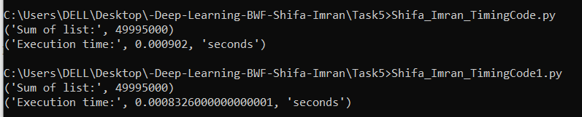

Creating a list using the [] syntax is slightly faster than using the list() function. This is because the [] syntax creates a new list directly, while the list() function has to call the list constructor to create a new list.

**Checking directly on shell.**

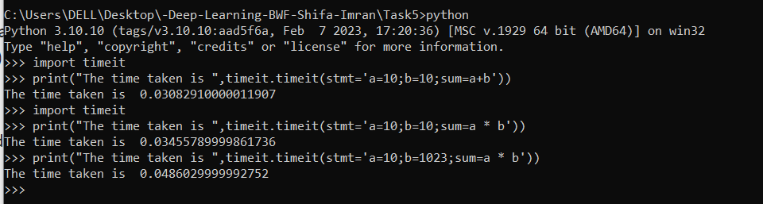

**Running TimingCode2.py**

